 | Autumn 1 | Autumn 2 | Spring 1 | Spring 2 | Summer 1 | Summer 2
Theme | How do we change?  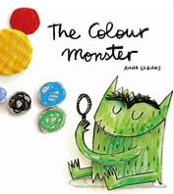 | How do we get there?  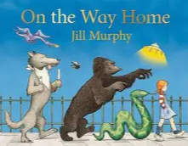 | How do you celebrate?  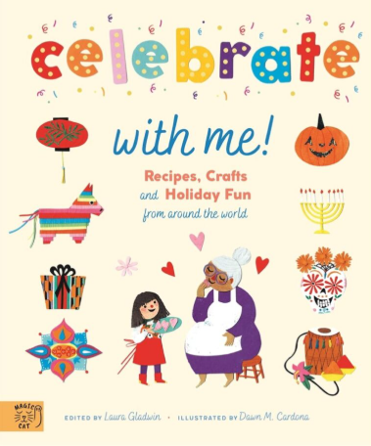 | If you go down to the woods today  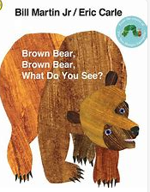 | How does your garden grow?  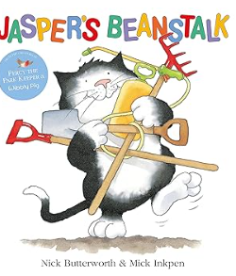 | Under the Sea  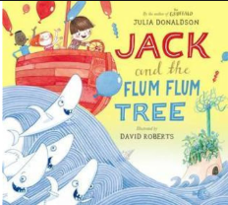
I AM | Unique | A wonderer | Understanding | Determined | Resilient | Collaborative
Quality texts | Healthy Me!  Colour Monster (2Y/N)  Which food will you choose? (2Y/N)  Ruby’s Worry (2Y/N)  Titch (R)  Perfectly Norman (R)  Oliver’s Vegetables (R)  The Enormous Turnip (R) | Duck in a Truck (2Y/N)  The Train Ride (2Y/N)  The Journey(2Y/N/R)  Martha’s Maps it out (R)  On My Way Home (R)  Nativity (R) | Mog’s birthday  Supertato Carnival Castastro-Pea  I love Chinese New year- non-fiction  Lunar New year around the world- Non fiction  Celebrate with me- non fiction | Deep Dark Wood  Brown Bear, Brown Bear. (2Y/N)  The Gruffalo (2YO/ N)  Owl babies (N)/2YO  We’re going on a bear hunt  Look what I found in the woods; National Trust (N/2YO)  The Gruffalo (R)  Owl Babies (R)  Goldilocks and the Three Bears (R)  Easter Story (R) | Growing and Changing  Jasper’s Beanstalk (2Y/N)  10 Chirpy Chicks (N/2YO)  Easter Story (N/2YO)  Titch (N/2YO)  (R)  The Little Red Hen (R)  Weather and seasons | Ten Little Pirates (2Y/N)  Tiddler (N/2YO)  Somebody Swallowed Stanley (2YO/N/)  Jack and the Flum Flum Tree (R)  The Odd Fish (R)  Night Pirates (R)  Non-Fiction Texts  Snail and the whale (R)  Big outdoors for little explorers (N/2YO)
Key vocabulary  NELI Text  Drawing club | Assessments  Neon Leon  3 Pigs  Cinderella  Toby and Tricky things  Copy Cat | Pip Posy  Dino Rocket  How to look after your dino  When dragon goes to school | The Knight who said no  Don’t wake Tiger | Nothing can frighten a bear  Look and say  What you see  Little red Riding Hood  Boy and Bear | Franklin Frog  Firefly Home  Jack and the beanstalk
Poems / Nursery rhymes | TwinkleTwinkle  Baa Baa Black Sheep | Nursery rhyme week | Wheels on the the bus  Incy Wincy Spider | 5 Little Speckled Frogs  5 Little ducks went swimming one day  How does your garden grow? | The Grand Old Duke of York  Old MacDonald had a farm  Dingle Dangle scarecrow | I hear thunder  Row Row Row your boat  Hey diddle diddle
British Values  Celebrations | Individual Liberty  Harvest  Sukkot  Navratri  Diwali | Mutual Respect  Bonfire night 5th Nov  Remembrance Day 11th  Anti-bullying week  St Andrew’s Day  Advent/Christmas  Hanukkah Dec (Judaism) | Mutual Respect  Shrove TuesdaySt  Chinese New Year | Mutual Respect  David’s Day  St Patrick’s Day  Easter  Ramadam | Respect and Tolerance | Democracy  Hajj (Muslim)
EYFS Extraordinary Experiences  Trips/ Visitors | 18.Dive into a good book | 1.Stomp through the leaves  5.Make a splash  16.Explore Natural materials  17. Experiment with colour  Local walks using our senses | 3.Chat to a visitor  8.Dive into different cultures  15.Explore different countries | World book day  Balance bikes  Owl centre  9. Let’s go on an adventure  11.Prepare and cook delicious food  19.Investigate artefacts | Chicks / duck eggs  Funky Monkey multi skills – Rec  7.Mini beast hunt  10. Ride a bike  11.Prepare and cook delicious food  13.See the process of a life cycle  20.Share a wow moment | Saltburn trip  RNLI  6.Play area adventure  4.Feel the sand between my toes  14.Become an author and create your own story  2.Plant it grow it, eat it.
Being part of the school community | Settling in routines  Exploring the school and grounds | Nativity performance  Watching other children’s performances  Parents workshop and crafts  Whole school Shine award | British science week  Children’s mental health week | Mother’s Day  Easter crafts  Parent workshop  Whole school Shine award | Litter pick around our school or local area  Visiting new buildings and sites (additional transition support)  Father’s day | Transition parent’s meetings and what to expect in Rec / Y1  Teddy bears Picnic  Fun Day  Nursery – Graduation  EYFS transition celebration  Whole school Shine award

Communication and Language

Personal, Social and Emotional Development
Personal, Social and Emotional Development | These statements have been split for extra focus, but all areas of the assessment document PSED will apply throughout the year.
Physical Development

Complete PE

Handwriting
Physical Development  Complete PE  Handwriting | Fundamentals of locomotion | Fundamentals of movement skills | Fundamentals of object control – ball skills | Fundamental of objects control – games | Dance - Basic moves,  (ABCs) Agility balance and coordination | Gymnastics  (ABCs) Agility balance and coordination

Literacy

Nursery
Reception
Phonics | Listening skills and sound awareness, oracy focus for Nursery including Fred talk.  RWI groupings and regular assessments for targeted teaching and additional support with fast track tutoring in Reception.
Mathematics  White Rose Maths | The yearly overview provides an at-a-glance progression of the mathematical areas and concepts throughout the nursery scheme. The 24 blocks can be accessed at any stage of children starting nursery. Timings are flexible to allow you to start the progression where developmentally appropriate as well as with children starting nursery in different intakes through the year or longer.
Nursery | More than, Fewer than, same  Explore and build with shapes and objects  Explore repeats  Hear and say number names | Begin to order number names  I see 1,2,3  Joining in with repeats | Explore position and space  Show me 1,2,3  Move and label 1,2,3  Explore position and routes | Explore patterns  Take and give 1,2,3,  Match, talk, push and pull  Talk about dots | Compare and sort collections  Lead on own repeats  Start to puzzle  Making patterns together | Make games and actions  Show me 5  My own pattern  Stop at 1,2,3,4,5  Match, sort, compare
Reception | Getting to know you  Match, sort and compare  Talk about measure and patterns  IT’s me 1,2 3 | Circles and triangles  1,2,3,4,5.  Shapes with 4 sides | Alive in 5  Mass and capacity  Growing 6,7,8, | Megth, height and time  Building 9 and 10  Explore 3-D Shapes | To 20 and beyond  How many now  Manipulate, compose and decompose | Sharing and grouping  Visualise, build and map  Make connections  Consolidate
Progression of skills -See additional White rose Calculation policy
Vocabulary progression document
Understanding the World
Expressive Arts and Design | Drawing  Junk modelling  Joining techniques  Colour mixing  Collage | Drawing with different tools  Malleable materials  Loose part art  Collage | Constructing with a purpose  Use of colour  Observational drawing  Painting | Role play  Observational drawing  Construct with a purpose  Printing | Plan, do, review  Printing  Scissor skills  Joining techniques | Collage  Portraits  Drawing with additional detail  Evaluate, revisit and enhance work.
Charanga REC
Fundamental skills | See fundamental skills development document for the progression of skills linking to each subject within the National curriculum to show how we are developing the core fundamental skills to get our children ready for school.

