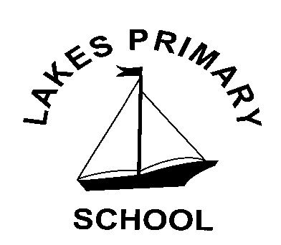
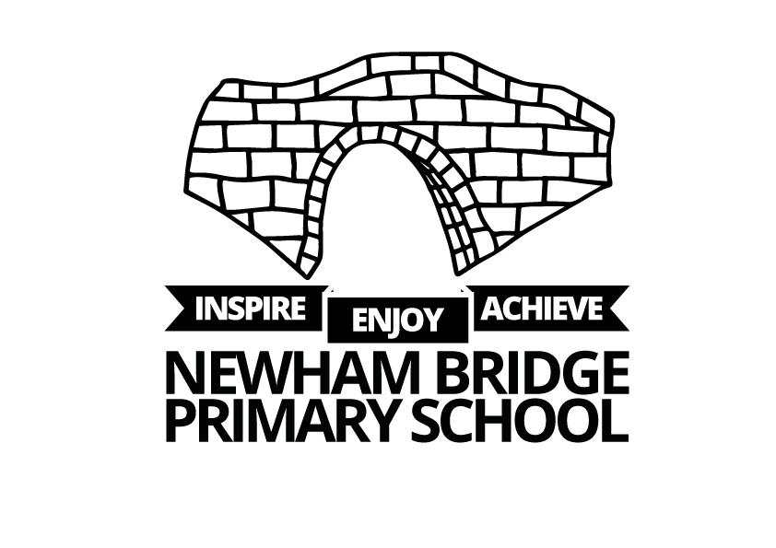
Lakes Primary School: Whole School Overview 2025-26

 | Autumn | Spring | Summer
KS1  Cycle A  24-25 | Toy Story  Study of toys past and present and how they have changed and evolved through history. | Hall of Fame  A study of people who have made significant contributions then and now. | Around the World  Know that there are 7 continents and 5 oceans. Look at the UK and its place in the world. Discover famous landmarks.
KS1  Cycle B  25-26 | London’s Burning  A study of The Great Fire of London, its significance and impact and legacy for today including our modern fire service. | Our Wonderful World  A study of animals and their habitats across the globe. Look at climate, seasons and changes in nature. | Land Ahoy!  Make links to the coast and local area including recognition of James Cook and Grace Darling.
LKS2  Cycle A  24-25 | Tribal Tales  Changes in Britain from Stone Age to Iron Age. | Redcar Rocks  Redcar then, now, significant local people and our place in the UK/World. | The Invaders  From Anglo Saxons, Vikings and Norman Conquest through to the Roman Empire. How did Britain change and develop?
LKS2  Cycle B  25-26 | Tudor Times  Tudor life, Henry VIII – including the plague. | Wonders of the World  Landmarks across the globe and their capitals. From Amazon to Sahara, natural disasters and climate zones. | Tomb Raiders  In depth study of Ancient Egypt, civilisation and legacy.
UKS2  Cycle A  24-25 | Fallen Fields  An in-depth study of WW1 and WWII including Remembrance Day and Wilfred Owen. | Global Goals  Climate change, pollution, food miles and overcoming adversity. | Viva La Mexico  Study of the Mayan Civilisation compared to modern day Mexico. Traditions and cultures.
UKS2  Cycle B  25-26 | Gods and Mortals  In depth study of the ancient Greeks, civilisation, beliefs and legacy. | Poles Apart  North and South Pole study inc. Scott, Shakleton and Skelton born Frank Wild. Climate change and future threats inc. polar bear threats. | The Victorians  Crime & punishment, life of Queen Victoria, inventions that changed the world.

